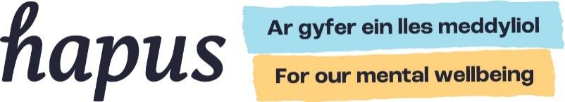
Conversation starter prompts 开启心理健康对话的话题提示
Sometimes it is hard to know how to begin a conversation about mental wellbeing. 有时我们很难知道如何开启关于心理健康的对话。
You can support Hapus in our mission to develop a shared understanding about mental wellbeing in Wales, by talking to people about the things that support good mental wellbeing and what can be done to protect and improve it.

Prompts that can help people to start talking： 以下提示可以帮助人们开始交流：
What helps you to feel good and function well?
什么能帮助你感觉良好，并保持更佳状态？
What do you enjoy doing in your spare time?
你闲暇时喜欢做什么？
What do you do to help reduce feelings of stress?
你通常会做什么来缓解压力？
What in your life brings you the most joy?
生活中让你最快乐的是什么？
What good things have you noticed recently?
你最近注意到了哪些美好的事情？
When did you last spend time in nature?
你上一次亲近大自然是什么时候？
When did you last try something new?
你上一次尝试新事物是什么时候？
How do you like to spend time with people you feel close to?
你喜欢如何与你亲近的人共度时光？
I feel most relaxed when…
我感到最放松的时刻是当…
The things that matter to me most are…
对我来说最重要的事物是…
I am grateful for…
我感恩的是…
The things that give me hope are…
给我带来希望的事情是……
I feel part of a community when…
当…时，我感到自己是群体的一部分
The most beautiful place near to where I live is…
我住的地方附近最美的地方是……
My favourite place to be is…
我最喜欢的地方是……

The Hapus website is a place where people can get ideas and inspiration for things they can do to boost their mental wellbeing:
www.hapus.cymru / www.hapus.wales

你可以通过与他人谈论哪些因素有助于良好的心理健康，以及如何保护和改善心理健康，来支持Hapus在威尔士推动建立对心理健康的共同理解这一使命。
Hapus 网站 是一个为人们提供想法和灵感的平台，帮助大家提升心理健康：
www.hapus.cymru / www.hapus.wales

